🔹 EXECUTE IMMEDIATE in PL/SQL (Oracle)
Oracle Database provides dynamic SQL support in PL/SQL using the EXECUTE IMMEDIATE statement.
EXECUTE IMMEDIATE is used when the SQL statement is not known at compile time and must be built and executed at runtime.

📌 What is EXECUTE IMMEDIATE?
EXECUTE IMMEDIATE executes a dynamic SQL string in PL/SQL.
👉 It can run:
- DDL statements (CREATE, ALTER, DROP)
- DML statements (INSERT, UPDATE, DELETE)
- Dynamic SELECT (using INTO)
- Stored procedure/function calls

🧠 Why Dynamic SQL?
Dynamic SQL is useful when:
- Table names change at runtime
- Column names are dynamic
- Conditions are built dynamically
- Admin scripts create/drop objects
- Generic procedures are required

🧾 Basic Syntax
EXECUTE IMMEDIATE sql_string;
With bind variables:
EXECUTE IMMEDIATE sql_string
INTO variable_list
USING bind_variable_list;

🧪 Example Setup (Table Creation)
CREATE TABLE emp_exec (
emp_id NUMBER,
emp_name VARCHAR2(50),
salary NUMBER
);
INSERT INTO emp_exec VALUES (1, 'Arun', 40000);
INSERT INTO emp_exec VALUES (2, 'Divya', 50000);
COMMIT;

1️⃣ EXECUTE IMMEDIATE with DDL
Example: Create Table Dynamically
BEGIN
EXECUTE IMMEDIATE '
CREATE TABLE dept_exec (
dept_id NUMBER,
dept_name VARCHAR2(50)
)';
END;
/
📌 Note:
DDL statements auto-commit in Oracle.

2️⃣ EXECUTE IMMEDIATE with DML (INSERT)
DECLARE
v_sql VARCHAR2(200);
BEGIN
v_sql := 'INSERT INTO Dept_exec VALUES (3, ''Ravi'')';
EXECUTE IMMEDIATE v_sql;
COMMIT;
END;
/

3️⃣ Using Bind Variables (Recommended ✅)
Example: Dynamic INSERT with Bind Variables
DECLARE
v_sql VARCHAR2(200);
BEGIN
v_sql := 'INSERT INTO emp_exec VALUES (:1, :2, :3)';
EXECUTE IMMEDIATE v_sql USING 4, 'Anita', 48000;
COMMIT;
END;
/
✔ Advantages
- Prevents SQL Injection
- Improves performance
- Reusable execution plan

4️⃣ EXECUTE IMMEDIATE with UPDATE
DECLARE
v_sql VARCHAR2(200);
BEGIN
v_sql := 'UPDATE emp_exec SET salary = :1 WHERE emp_id = :2';
EXECUTE IMMEDIATE v_sql USING 60000, 2;
COMMIT;
END;
/

5️⃣ EXECUTE IMMEDIATE with SELECT INTO
Dynamic SELECT must return only one row.
DECLARE
v_salary emp_exec.salary%TYPE;
v_sql VARCHAR2(200);
BEGIN
v_sql := 'SELECT salary FROM emp_exec WHERE emp_id = :1';
EXECUTE IMMEDIATE v_sql INTO v_salary USING 1;

DBMS_OUTPUT.PUT_LINE('Salary: ' || v_salary);
END;
/
📤 Output
Salary: 40000

6️⃣ EXECUTE IMMEDIATE for DROP TABLE
BEGIN
EXECUTE IMMEDIATE 'DROP TABLE dept_exec';
END;
/

7️⃣ Calling Procedure Using EXECUTE IMMEDIATE
BEGIN
EXECUTE IMMEDIATE 'BEGIN my_procedure(:1); END;' USING 100;
END;
/

⚠ Important Rules & Notes
Rule | Explanation
Single SQL statement | Only one statement at a time
No compile-time validation | Errors occur at runtime
DDL auto-commit | Cannot rollback
SELECT must return one row | Else ORA-01422 error
Use bind variables | For safety & performance

❌ Common Errors
ORA-00933
SQL command not properly ended
➡ Incorrect SQL syntax
ORA-01422
exact fetch returns more than requested number of rows
➡ SELECT returned multiple rows

🔁 EXECUTE IMMEDIATE vs Static SQL
Static SQL | EXECUTE IMMEDIATE
Known at compile time | Built at runtime
Faster | Slightly slower
Safer | Needs bind variables
Simple logic | Dynamic/admin scripts

🧩 Real-World Use Case
🔹 Admin Utility Procedure
- Create monthly tables
- Archive old data
- Dynamic reporting queries
- Multi-tenant schemas

🖼️ Conceptual Flow (Dynamic SQL)
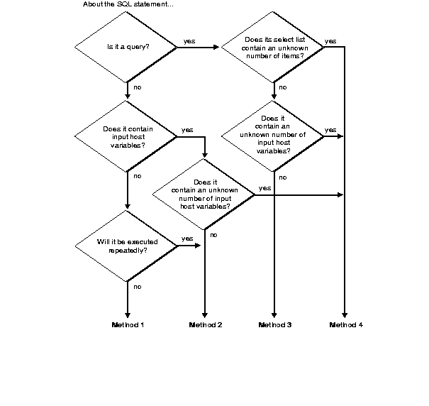
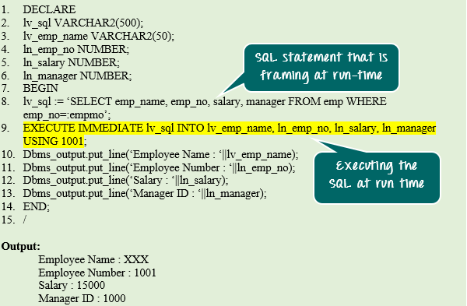

✅ Summary
- EXECUTE IMMEDIATE executes dynamic SQL
- Used for DDL, DML, SELECT, procedure calls
- Always prefer bind variables
- Errors appear at runtime
- Very powerful for generic & admin scripts

